**Wisconsin Newborn Screening (NBS) Program:**

**An Introduction**

*A free enduring online continuing education opportunity*

***Did you know? Not all parent/guardians are notified of their infants' NBS results and/or needed referrals that were made.***

This activity is intended for pediatric clinicians who wish to improve their understanding of the NBS process, communication of NBS results with parent/guardians and making appropriate referrals. This activity was created by geneticists, genetic counselors, pediatricians, public health representatives, the Wisconsin State Lab of Hygiene and parents.

**Target Audience**

MD, DO, RN, APRN, LPN, PA, RDN, Midwives, Genetic Counselors, Phlebotomists

**Learning Objectives:**

Participants completing this CME module will be able to:

* Describe the Wisconsin Newborn Screening (NBS) program – what conditions are included and how conditions are added to the panel.
* Provide education to families about the NBS process and the difference between a screen and a diagnostic test.
* Define possible NBS results, identify when further action is required and identify resources for providers and families.
* Communicate with families about NBS results and next steps following positive and borderline NBS results.

**Available credit:**

* **0.75** MOC: ABIM Medical Knowledge Points (Part II)
* **0.75** MOC: ABP Lifelong Learning Points (Part II)
* **0.75** AMA PRA Category 1 Credit™
* **0.75** ANCC Contact Hours
* **0.75** University of Wisconsin–Madison Continuing Education Hours

**0.75** Approved for AMA PRA Category 1 Credit™

**Cost: $0.00**

**TIME TO COMPLETE:** 50 minutes

**REGISTER:** [**2022 Wisconsin NBS Program: An Introduction**](https://ce.icep.wisc.edu/2022-wisconsin-nbs)

[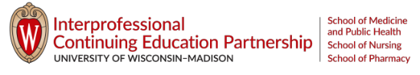](https://ce.icep.wisc.edu/)